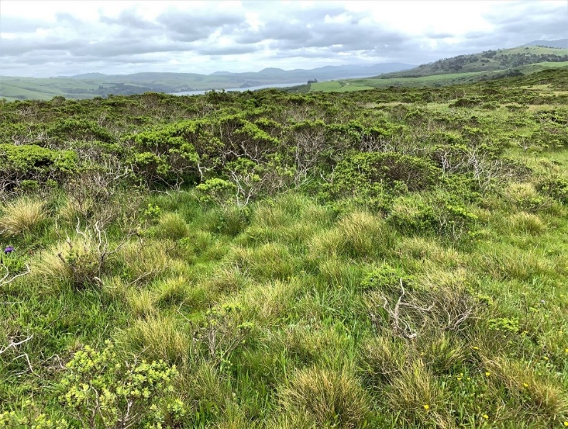
Photo: Courtesy of Laura Cunningham

POINT REYES: A WILDERNESS IN PERIL
Online Discussion
Weds. June 3rd at 6pm

Join a team of conservationists, biologists, film-makers and local leaders to learn more about our backyard paradise and how it’s being threatened by pollution, habitat loss and giveaways to private industry.

Chance Cutrano, of Resource Renewal Institute will present on the following topics: Explanation of Enabling Legislation of Point Reyes National Seashore, ranch leasing agreements and the Organic Act.

Find out how the National Park Service is proposing to further privatize our public land and what you can do to protect and restore the scenic and natural beauty of Point Reyes National Seashore for generations to come.

RSVP REQUIRED

RSVP here:
https://form.jotform.com/201495736265966
To view the opening video presentation, go to:
https://youtu.be/pDLuY4yslVk

